Leave of Absence Policy
Mainstay understands there are moments when you’re not able to work due to certain situations. Review the information below for the types of leave of absences (LOA) that may be available to you, find out how you can apply for a LOA, as well as other important information & helpful resources.
If you have any additional questions, please contact hr@mainstay.io Effective May 1, 2024 - Unum is our leave of absence, disability and accommodations administrator.

Common Reasons for a Leave of Absence
Depending on your reason for leave, you may be eligible for multiple leaves which run concurrently.
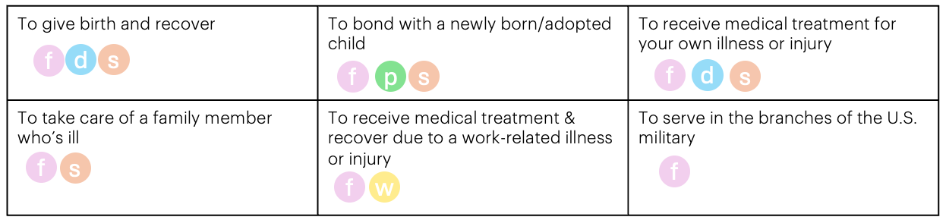
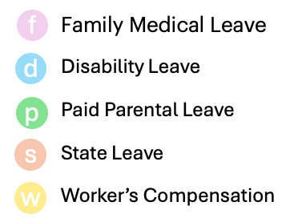

Requesting a Leave of Absence
Effective August 1, 2024, Mainstay has partnered with Unum to be our leave of absence and accommodation administrator. If you have a leave of absence that is scheduled to begin after August 1, you must initiate a claim through Unum.
Leave of Absence Process
- At least 30 days in advance, when possible, fill out the Leave of Absence Request Form.
- Once reviewed, the People team will review and schedule a formal intake meeting within 5 business days.
- The People team will review your request form live with you to confirm all details and gather any additional needed information.
- Speak with your direct manager to review roles and responsibilities and what coverage will be needed.
- Submit a claim through Unum here. Provide Unum with all the required documentation and authorizations by the requested due dates.
  - How To Submit an LOA
  - An example claim form can be viewed here.
- ❏ Notify Unum & the People team when you plan to return to work and if you need any accommodations such as a modified work schedule or equipment.
Dates Matter. If you are changing the dates of your leave, it’s important to notify Unum and the People team immediately. Date changes and late reporting often result in delayed pay.

Employee | Manager | People Team | Unum
-Speak with your manager & people team by filling out the LOA request form  -Submit claim form to Unum  -Notify Unum with any changes  -Pay back any missed premiums while on leave, if applicable  -Enroll dependents in coverage (if applicable) | - Notify the People team of the requested leave  -Notify the People team of any performance concerns prior to employees' leave  -Review & approve accommodation requests in partnership with People Team | -Conduct intake meetings with employee  -Review LOA details and benefit payment information  -Review & approve accommodation requests in partnership with employees manager | -Receives disability claim form & reviews  -Requests Employer statement to confirm details  -Proccesses claim and mails statement with necessary LOA dates and payment information  -Continues to manage and track leave and communicates with healthcare provider regarding certification
IMPORTANT:
Your Paycheck  If you are on a leave for a portion of a pay period, your paycheck may be impacted and will be adjusted on the following paycheck. This is due to Mainstay’s payroll processing times and they may need to do a retroactive adjustment that may result in money owed to you or money owed to the company. | Your Benefit Premiums  If you are on a paid leave, your benefits premium will automatically be subtracted from your pay.  If you are on an unpaid leave, you will pay your unpaid premiums once you return to work. Your premiums will be doubled (current deductions owed plus one extra deduction) each pay period until outstanding balance is paid in full. | Add your new Dependents to Mainstay benefits!  When you experience a qualifying life event (QLE) such as birth/adoption of a child, you have 30 days to enroll in any newly eligible dependents. In many instances newborns are covered for 30 days as part of the labor & delivery benefit. If you wish to enroll the newborn in Mainstay’s benefits, you must enroll them within 30 days of birth.

FAQ
Explain how leaves run concurrently?
Depending on the situation, you may be eligible for more than one type of leave at the same time. Below is an example of someone who needs a leave of absence for giving birth. This person's FMLand STD would run concurrently and their FML and Mainstay's paid parental leave would run concurrently. Depending on where this person works, she may be entitled for additional state mandated leaves.
What is intermittent leave?
Intermittent leave is when you or a covered family member has a condition which requires you to be away from work sporadically, either on a reduced schedule or to miss entire days.
What does an elimination/waiting period mean?
If you apply for a short term disability leave, the elimination period refers to the time after you're disabled until you can begin to receive STD benefit payments. This is 7 calendar days which means you can use your available sick/PTO/FTO for the elimination period otherwise that portion of your leave is unpaid.

